**Focus keyword**: Bowmar Nutrition

**Meta Title:** Bowmar Nutrition – vigoursoul

**Meta Description:** Bowmar Nutrition, which Sarah Bowmar and Josh Bowmar co-own, was founded in 2018 in response to the urgent demand for clean, healthy food.

**Feature Image:**

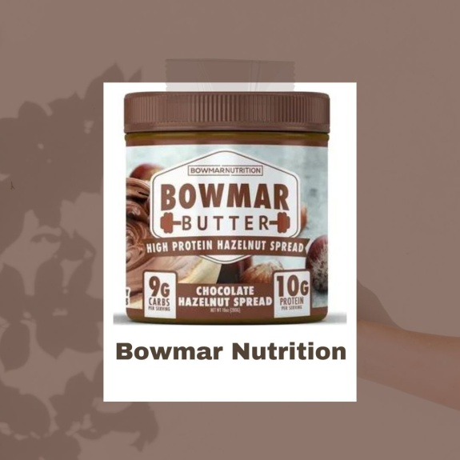

**Bowmar Nutrition**

Bowmar Nutrition, which was established by Josh and Sarah Bowmar, is where you may get supplements of the greatest possible quality and flavour. By creating a new standard for the supplement business, our objective is to improve lives through health and wellbeing. We take pride in our premium supplements, which feature cutting-edge ingredients, unrivalled production techniques, and rigorous testing.

At addition to being third-party tested in an ISO 17025 lab, all goods are manufactured in a GMP-certified and FDA-accredited facility. Customers may shop for Bowmar Nutrition's large selection of goods online at http://bowmarnutrition.com and in-person at a few chosen merchants across the world.

**Josh Bowmar and Birth of Bowmar Nutrition:**

Josh Bowmar is a recognised authority in fitness, nutrition, and hunting. He is also an entrepreneur, author, podcast presenter, and a former All-American college athlete.

Josh Bowmar was a track and field All-American collegiate athlete who also played on the football team, so staying in top shape was very important to him. He discovered what it takes to optimise the body's performance as an exercise physiology student. He put this knowledge to the test while in college by competing in bodybuilding competitions and breaking four school records in track and field. He won several competitions in bodybuilding, including the 2012 and 2013 Arnold Classic Men's Physique Overall Championships, Mr. Ohio Class Winner and Overall Champion, and Natural Northern USA-Drug Tested.

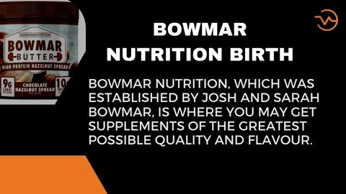

He won the Men's Physique Class and Overall Championship in the Great Lakes Men's Physique Competition, took first place at the 2013 NPC National Bodybuilding Championship, and was given IFBB Pro Men's Physique Status.

Josh has always been passionate about exercise and nutrition. While competing in the 2014 Arnold Classic in Columbus, Ohio, he first met his wife, Sarah Bowmar, and they got engaged the following year. In 2014, Josh and Sarah received joint certifications from ISSA as fitness trainers and nutrition professionals. In the same year, Sarah and Josh started a joint online coaching company called Bowmar Fitness. In 2018 and 2020, respectively, they created the clean nutrition-focused businesses Bowmar Nutrition and APEX Protein Snacks in response to the demand for healthier, cleaner products.

**Josh Bowmar Hunting:**

Josh Bowmar has enjoyed bowhunting and being outside since he was a small child. With only their bows and arrows, he and Sarah now hunt together all over the world, with their favourite locales being Alaska and Africa. They have had the chance to give back through hunting by providing tens of thousands of meals to families in Mozambique and South Africa. The Bowmars are devoted to stopping poaching, which they accomplish through encouraging moral hunting practises and aiding the Dallas Safari Club's anti-poaching initiatives. Josh and Sarah own Bowmar Archery, where you can buy their branded archery equipment and supplies like their innovative nose button. You can read about their adventures, bowhunting advice, and large game hunting experiences.

**Bowmar Nutrition Lawsuit:**

The action against Bowmar Nutrition is also being contested on the basis that customers cannot assert that their interests were injured by deceptive product claims after learning about them. Twelve people have filed a lawsuit against Bowmar Nutrition, which has its headquarters in Ankeny, asking for class-action status for their claim and more than $5 million in damages.

Consumer fraud, dishonest business tactics, and unfair enrichment on the part of the firm are among the claims made in the complaint, which was started last October. Individual customers who reside in Iowa, Texas, New Jersey, California, Florida, and other states are the case's plaintiffs. They argue that in making its claims, Bowmar made representations concerning the protein composition of its protein-fortified goods, including nutrition bars and powders.

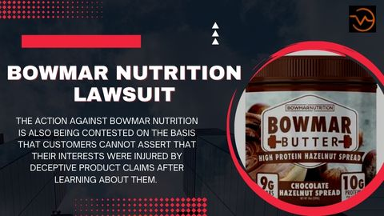

The plaintiffs contend that these assertions, which are presented on product labels and the business' website, vastly misrepresent the quantity of protein in each product. Consumers claim that testing by recognised laboratories has shown that some of the goods produced by Bowmar contain 10% to 67% less grammes of protein than claimed. The consumers assert that Bowmar's "fraudulent and misleading behaviour" caused them economic harm.

**Bowmar Nutrition Lawsuit 2022:**

As originally written, the lawsuit's claims are based on 12 different states' false-advertising statutes. The court hasn't made a decision about Bowmar's request to dismiss the second petition. The Consumer Products Association, a nonprofit organisation with offices in California, sued Bowmar Nutrition in federal court based on such claims of misleading labelling last year.

In that action, the CPA asserted that rather than the 10 grammes of protein stated on the label, various Bowmar nut spreads really contained between 4.7 and 8.6 grammes of protein per serving, according to testing it had commissioned.

The action was rejected after a court determined that because the group was primarily created to look into such problems, it had not been affected by the alleged fraud. U.S.: "It is evident that CPA lacks footing here." Thomas Whelan, district judge, made a decision. "The fact that labelling laws are broken does not hinder the work of an organisation established to promote their enforcement. The organisation would require a new mission if such transgressions didn't occur.

**Bowmar Nutrition Melt:**

When combined with a calorie deficit, MELT amplifies fat loss by dissolving fat cells and using them as fuel. With 22 clinically validated ingredients designed to improve metabolic health, increase fat mobilisation, and increase your body's capacity to oxidise fat, Bowmar MELT accelerates stubborn fat loss created as a thermogenic to enhance metabolic health and reduce cravings. You may enjoy both stim and non-stim (stimulant free, i.e. coffee) recipes at any time of day.

**Bowmar Nutrition Collagen:**

Bowmar Nutrition Protein while bolstering healthy joints and cartilage, it supports youthful skin, hair, and nails. Collagen peptides (types I and III) from grass-fed bovines, 20g, in powder

Your preferred protein or drink blends seamlessly with it.

**Bowmar Nutrition Fiber:**

Bowmar fiber makes it simple to take advantage of the many health advantages of fibre, including better digestion, decreased cholesterol levels, and ideal blood sugar control. The prevention of some malignancies, heart disease, diabetes, and food allergies is also linked to adequate fibre consumption. For the greatest outcomes, Bowmar Nutrition fibre includes both soluble and insoluble fibre.

Cleanses your intestines of pollutants and enhances regularity .Packed with psyllium husk and Fibserol® non-GMO soluble maize fibre in therapeutic concentrations to assure the optimum outcomes. Includes both soluble and insoluble fibre types.

The numerous health advantages of fibre, such as enhanced digestion, decreased cholesterol levels, and ideal blood sugar control, are simple to enjoy with Bowmar Fiber. In order to achieve the optimum effects, Bowmar Nutrition Fiber combines both soluble and insoluble fibre.

Bowmar Nutrition Fiber can be consumed on a one-time basis to relieve constipation or on a daily basis to aid in promoting regularity and general digestive health.

**Bowmar Nutrition Controversy:**

Consumers claim that testing by recognised laboratories has shown that some of the goods produced by Bowmar contain 10% to 67% less grammes of protein than claimed.

**Bowmar Nutrition Coupon Code:**

Other leading vitamin companies in competition with Bowmar Nutrition include UMZU, Swanson Vitamins, and Puritan's Pride. In the fiercely competitive online vitamins and supplements market, Bowmar Nutrition offers mid-range buy size products for sale on both its own website and partner websites.

When it comes to giving discounts and discount codes, Bowmar Nutrition does it only sometimes. Despite having a relatively modest amount of coupons produced, Bowmar Nutrition is one of the most sought-after companies when it comes to coupons and discount offers, with hundreds of thousands of searches every month.

There are currently 34 Bowmar Nutrition discount codes available for use at bowmarnutrition.com. At bowmarnutrition.com, customers may get discounts that average 11.2% off, with the greatest coupon discount today being $5 off your order.

**Bowmar Nutrition-FAQS**

**How many vegetable servings are in a cup of Bowmar greens?**

Over 12 servings of fruits and vegetables are included in one scoop of greens, providing you with the essential vitamins, minerals, enzymes, and antioxidants for good health. Mix 1 scoop with 6-8 ounces of water and take it before breakfast on an empty stomach for best effects.

**Isolated Bowmar protein, is it?**

The Best-Tasting Protein Powder is Bowmar Nutrition's 100% Whey Protein Powder. Protein Meal Replacement using Whey Isolate. Protein content per serving is 22g.

**Bowmar nutrition was established by who?**

Josh and Sarah Bowmar are the co-owners of Bowmar Nutrition, which they founded in 2018 in response to the market's urgent need for goods that were nutritious, clean, and healthy. On their Bowmar Fitness YouTube Channel, they also share their suggestions for eating well and exercising.

**What kind of collagen is Bowmar nutrition?**

30 servings of Bowmar Nutrition's Type 1 and Type 3 Collagen Peptides, Collagen Powder, One Ingredient, Unflavored Collagen. Free of sugar, gluten, and dairy. Health of the skin, joints, and hair

**Is Bowmar Nutrition endorsed by the FDA?**

In addition to being third-party tested in an ISO 17025 lab, our products are manufactured in a facility that is GMP certified and FDA accredited. All of the ingredients we use are of the highest calibre and are tested before being manufactured.

**Is Bowmar Nutrition a trustworthy business?**

21 reviews for Bowmar Nutrition have a median rating of 3.45 stars, which suggests that most consumers are usually happy with their purchases. The 18th-ranked nutrition website is Bowmar Nutrition.

**Are promo codes the same as coupon codes?**

Promo codes, often referred to as discount codes, coupon codes, and offer codes, are alphanumeric codes that consumers can enter during the checkout process to save money on a purchase. They are commonly used in e-commerce.

**Conclusion**

Bowmar Nutrition Type 1 and Type 3 Collagen, Collagen Peptides, Collagen Powder, One Ingredient, 30 Servings. Sugar, gluten, and dairy are all absent. Boost the health of your skin, joints, and hair.

With 21 reviews and a customer rating of 3.45 stars, Bowmar Nutrition has demonstrated that the majority of customers are generally happy with their purchases. Among websites for nutrition, Bowmar Nutrition is ranked number 18.